The Nautilus DevOps team is developing a simple 'To-Do' application using DynamoDB to store and manage tasks efficiently. The team needs to create a DynamoDB table to hold tasks, each identified by a unique task ID. Each task will have a description and a status, which indicates the progress of the task (e.g., 'completed' or 'in-progress').
Your task is to:
- Create a DynamoDB table named datacenter-tasks with a primary key called taskId (string).
- Insert the following tasks into the table:
  - Task 1: taskId: '1', description: 'Learn DynamoDB', status: 'completed'
  - Task 2: taskId: '2', description: 'Build To-Do App', status: 'in-progress'
- Verify that Task 1 has a status of 'completed' and Task 2 has a status of 'in-progress'.
Ensure the DynamoDB table is created successfully and that both tasks are inserted correctly with the appropriate statuses.

Use below given AWS Credentials: (You can run the showcreds command on aws-client host to retrieve these credentials)
Console URL | https://997919949869.signin.aws.amazon.com/console?region=us-east-1
Username | kk_labs_user_552112
Password | xmC8L^^Kqqdq
Start Time | Tue Jan 13 08:41:20 UTC 2026
End Time | Tue Jan 13 09:41:20 UTC 2026
Notes:
- Create the resources only in us-east-1 region.
- To display or hide the terminal of the AWS client machine, you can use the expand toggle button as shown below:
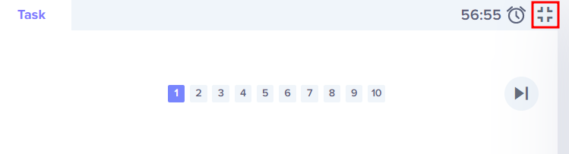

Solutions:-
2: Create DynamoDB Table
- Navigate to DynamoDB service.
- Click Create table.
- Configure:
  - Table name: datacenter-tasks
  - Partition key (Primary key): taskId (String)
  - Leave sort key empty (not needed here).
  - Keep default settings for capacity (on-demand recommended).
- Click Create table.
- Insert Tasks
datacenter-tasks
Click on the Explore table items
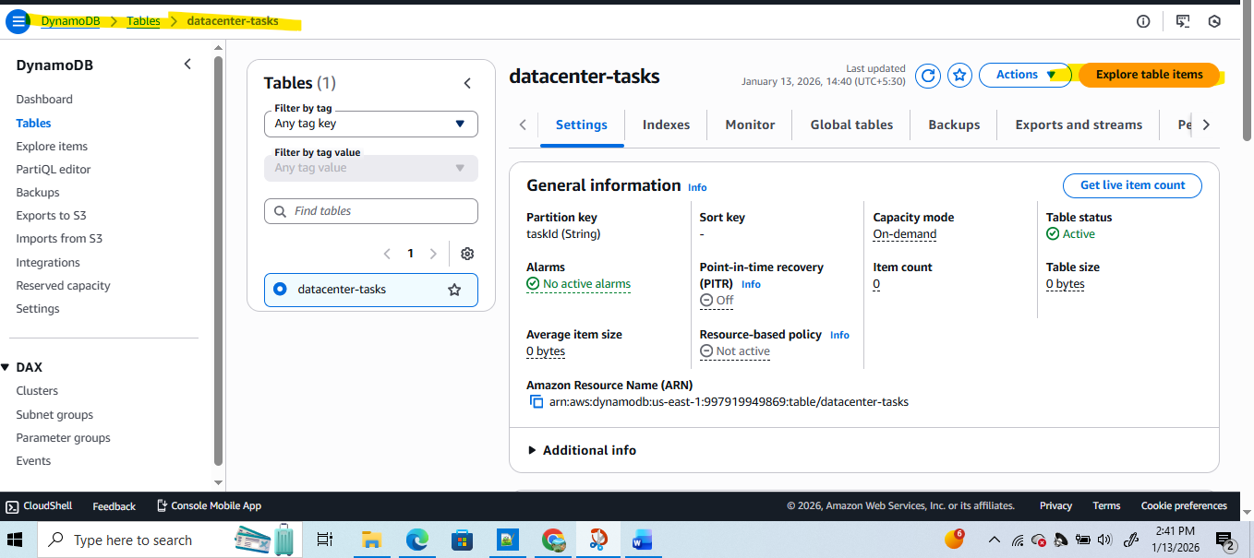

• Go to Items → Create item.
• Insert Task 1:
taskId": "1", "description": "Learn DynamoDB", "status": "completed"

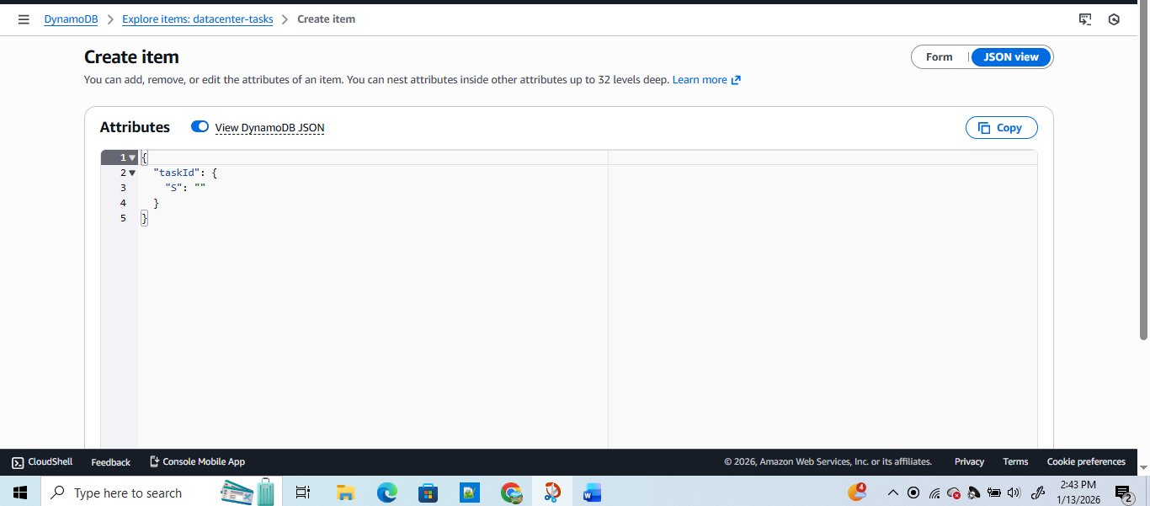

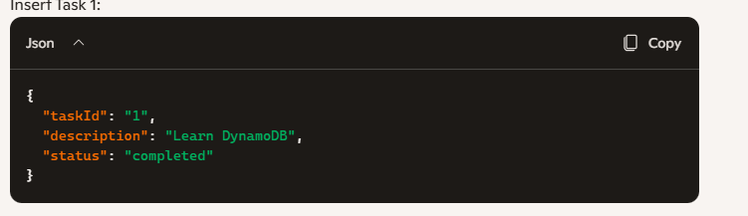
And save it .
• Go to Items → Create item.
• Insert Task 2:

"taskId": "2", "description": "Build To-Do App", "status": "in-progress"
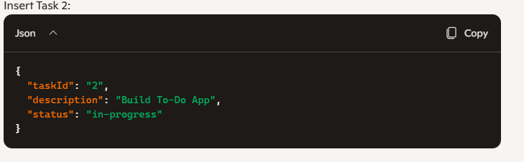
Verify Tasks
Run a query or scan:
